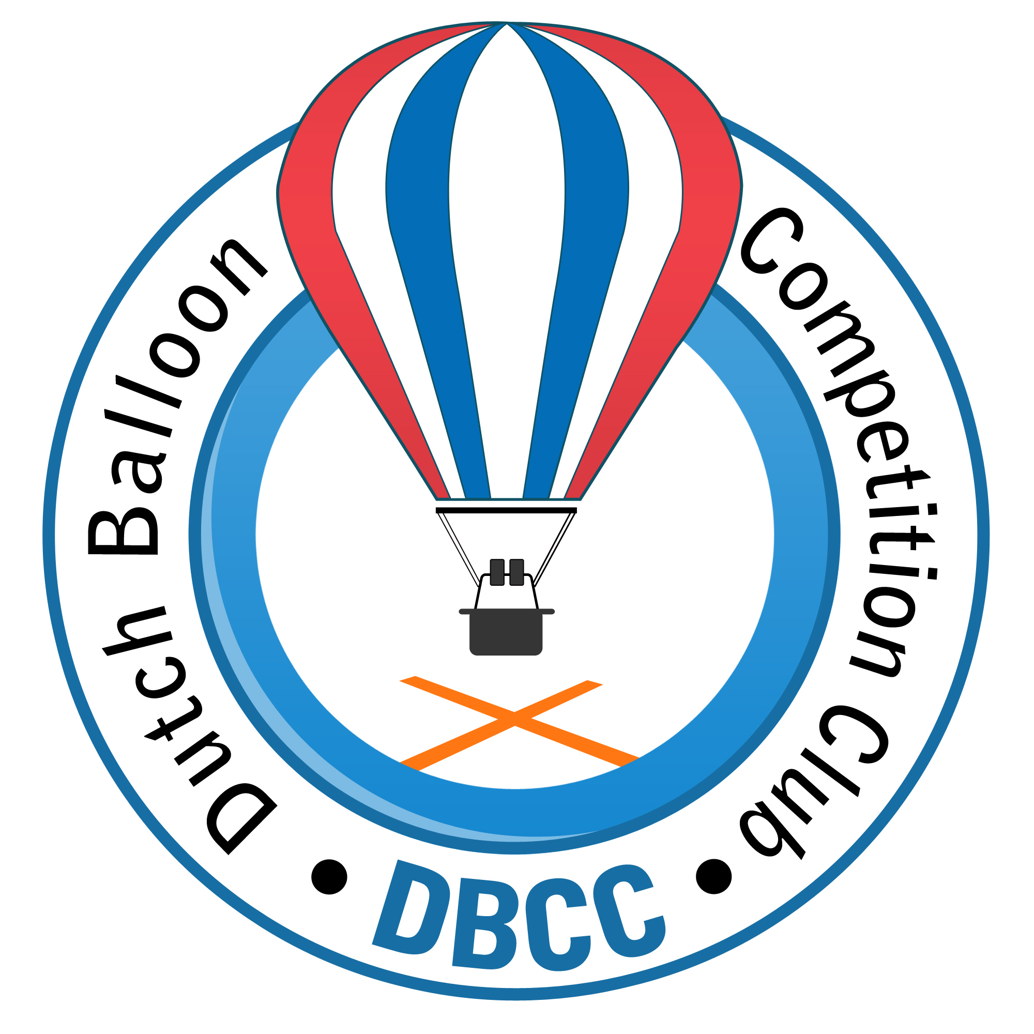
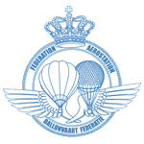
Invitation for:

DUTCH BALLOON TROPHY 2014
Wezuperbrug (NL - Drenthe)
28 May u/i 1 June 2014

36 th Dutch Championships and Belgian Championships 2014
and Pre-Woman’s European Hot Air Ballooning Championship 2014

The competition will be organised by the Dutch Balloon Competition Club on behalf of the KNVVL and in co-operation with the sports committee of the KBBF.
Location:
Molecaten Park Kuierpad
Oranjekanaal NZ 10
7853 TA Wezuperbrug (NL)
Telephone: 0031-591-381415 Fax: 0031-591-382235
E-mail: kuierpad@molecaten.nl

Competition Direction: Mathijs de Bruijn (NED)

Rules: According latest AXMER rules and with FAI loggers.
Date: 28 may u/i 1 june 2014
Check-in: 28 may 2014 between 18.30/19.30 at the competition centre
General Briefing: 28 may 2014 in the evening at 20:00 in the briefingtent
First flight: Thursday morning 29 may 2014
Last flight:: Sunday morning 1 june 2014 (except rule 1.2.2)
Price giving: Sunday 1 june 2014

Entry closing date: 13th April 2014

Entry fee: € 350,- incl. 2 maps (with PZ,s and other competition data).

Accommodation: At the park you can rent 6 persons bungalows for the reduced price
of € 402,40 until the 13th of january 2014 after this day the price will be higher (period: Wednesday appr. 15.00 hr until price giving). Booking can be done on the website of the Park: http://www.molecaten.nl/kuierpad/bungalow
For the first time it’s also possible to book a chalet for the reduced price
of € 320,70 also until the 13th of january 2014
http://www.molecaten.nl/kuierpad/chalet
Both are situated close to the launch field and the briefing tent.

Meals: There is a possibility to have meals with coffee and cakes before morning flight, breakfast after morning flight and dinner before evening flight. Costs € 15,00 pro person per day (total € 45,00 pro person for Thursday u/i Saturday). Tickets for Sunday incl. Gala dinner/buffet will cost € 17,50,- p.p. Tickets will be handed out at check-in.

Propane: The used amount will be charged after the competition at cost price.

Insurance: According European regulations.

Entry form: Can be sent before 13 April 2014 to:

Dutch Balloon Competition Club
De Gheynstraat 10
6717 RG EDE
info@dbcc.nl
or to:

Bert Stuiver, Dilweg 1,
7873 BN Odoorn.e-mail info@high5ballooning.nl
Tel: 0031-591-513467 mob. 0031-646204401

Entry is valid after receiving entry fee before 14 april 2014.
Account number 3822.45.709
IBAN NL17 RABO 0382 2457 09
BIC code: RABONL2U
Attn. Dutch Balloon Competition Club.

More INFO you can find or will be published on the websites:
www.dbcc.nl www.nkballonvaren.nl www.molecaten.nl/kuierpad

